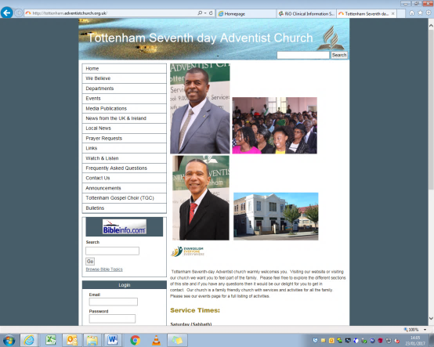ATurco-GPRE-20171018.pdf

**CONTACT Watch & Follow Us**

253-255 West Green Road N15 5EG

**Telephone** 020 8802 1477

**MOBILE** 07914 966 387

**Email** Tottenhamsda@hotmail.com

**Facebook** TottenhamsdaWestgreen

**YouTube** Tottenham sda church

www.tottenham.adventistchurch.org.uk

**Pastor:**

Dr Jude Jeanville

Tel: 07561 896 711

jude.m.jeanville@gmail.com

Surgery: Wed 11am – 8pm

*Ring to book an appointment*

**First Elder:**

Roger Charles

Tel: 07961 931 917

rogercharles2000@hotmail.com

**Church Clerk:**

Stacey Marshall

Tel: 07957 591 294

stacey.marshall@blueyonder.co.uk

**Head Deacon:**

Earl Grant

Tel: 07859 050 963

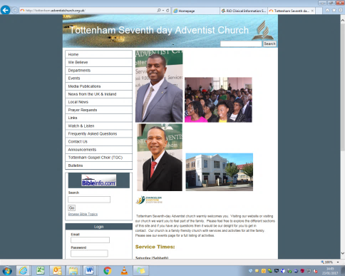



01 Juliette Ferdinand

08 Marion Wadibia

09 O’Dale Fitzgerald

10 Cody Marshall

**Health & Wellbeing PRAYER**

Sis L Beckford (Stamford N/Hm)

Sis N Sinclair (Wakefield Rd C/Hm)

Bro B Riley (Wakefield Road C/Hm)

Sis V Strachan & Family

Sis D Smith & Family

Bro F Bramble & Family

Sis M Napier-Vincent

|  |  |
| --- | --- |
| Sis M Silcott  Sis A Sithole  Sis M Gayle  Sis Modeste | Bro T Joseph  Sis B Amartey  Bro M Bucknor  Sis E Ifill |
|  |  |

**TOTTENHAM**

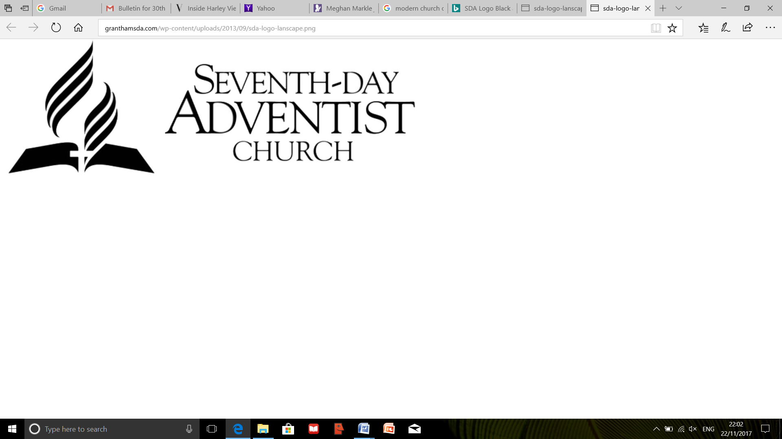



**Sabbath 21 July 2018**

Sabbath School 9.30 am

Opening Remarks

Opening Hymn 1 Sis J Joseph

Opening Prayer Sis J Joseph

Scripture Reading Acts 2: 46 & 47 Sis Wilson

***Lesson Study – Elder S Munroe***

**Lesson 3**

**Life In The Early Church**

**Acts 2:46, 47**

Welcome Eld A Gordon

Mission Story Sis J Brown

Special Item Bro N Irish

Closing Remarks

Closing Prayer Bro Maxwell

**Department Promotion**

**Announcements**

Please be mindful of where your children are **AT**

**ALL TIMES** and ensure that they are supervised especially when they use the toilet facilities.

Divine Service 11.05 am

Introit Praise Team

Call to Worship James Awotwi

Welcome O Simmons

Children’s Story –

Tithes and Offering C Simmons

Garden of Prayer D Atkinson

Praise & Worship Praise Team

Opening Hymn 251

Scripture Reading Rev 3:7,8 Elder S Hudson

Meditational –

**Del & Co**

Introduction of Speaker

**Sermon** Elder S Hudson

Closing Hymn Praise Team

Benediction Elder O Baxter

After the service please remain seated.

The Ushers will lead you out **reverently and quietly.**

**TODAY’S Meeting**

TBA

**SUNSET Times**

20 July - 21:07 27 July – 20:58

03 Aug - 20:47 10 Aug - 20:34

**On Duty THIS MONTH**

Elders: Daniel Soyam & Marion Wadibia

Deacon: Earl Grant

First Aiders: Suzette Rodgers & Rosanna Russell

**Church at PRAYER**

Prayer Line - 020 8802 1477

Prayer Meeting - Wednesday 7.30pm

The Offering collected

after the Children’s Story

is in aid of our Building Fund

**BE AWARE**

The metal pipes under

the seats, are the heaters!

**Announcements**

* **The Service** can be watched on YouTube and from our Website
* **Women’s Ministry** – “End it Now March” - **Postponed**
* **During the Renovation** - Our worship address is:

West Green Baptist Church, 182-184 West Green Road, London N15 5AF

*You are welcome to eat a light lunch in the hall after the service until 4pm*

**BULLETIN SUBMISSIONS:** By 6:00pm on Tuesday

Send your email to: **Tottenhamsda@hotmail.com**

**MONTH’S Planner**

|  |  |  |  |  |
| --- | --- | --- | --- | --- |
| **Date** | **28 July** | **4 August** | **11 August** | **18 August** |
| **Call** | Ranika M | Cai M | Xana-Marie R | Keeti Tolera |
| **Story** |  |  |  |  |
| **Song** | Kelly Hunter | N Riley | D Thompson | S Malcolm |