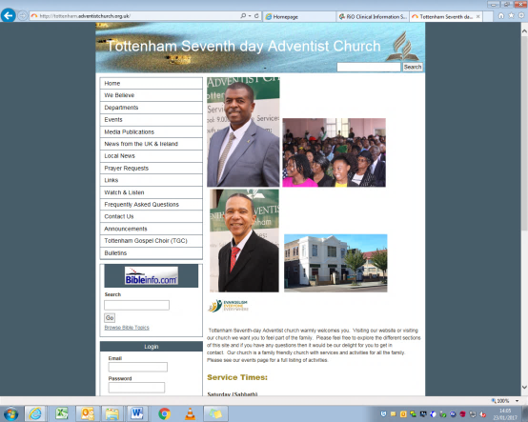ATurco-GPRE-20171018.pdf

**CONTACT Watch & Follow Us**

253-255 West Green Road N15 5EG

**Telephone** 020 8802 1477

**MOBILE** 07914 966 387

**Email** Tottenhamsda@hotmail.com

**Facebook** TottenhamsdaWestgreen

**YouTube** Tottenham sda church

www.tottenham.adventistchurch.org.uk

**Pastor:**

Dr Jude Jeanville

Tel: 07561 896 711

jude.m.jeanville@gmail.com

Surgery: Wed 11am – 8pm

*Ring to book an appointment*

**First Elder:**

Roger Charles

Tel: 07961 931 917

rogercharles2000@hotmail.com

**Church Clerk:**

Stacey Marshall

Tel: 07957 591 294

stacey.marshall@blueyonder.co.uk

**Head Deacon:**

Earl Grant

Tel: 07859 050 963

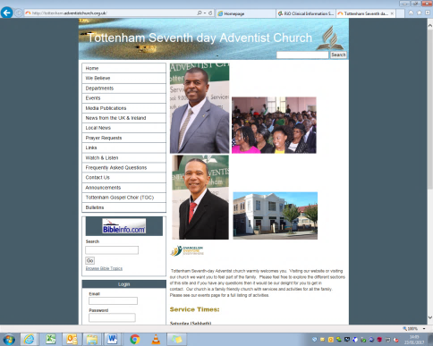



01 Juliette Ferdinand

08 Marion Wadibia

09 O’Dale Fitzgerald

10 Cody Marshall

**Health & Wellbeing PRAYER**

Sis L Beckford (Stamford N/Hm)

Sis N Sinclair (Wakefield Rd C/Hm)

Bro B Riley (Wakefield Road C/Hm)

Sis V Strachan & Family

Sis D Smith & Family

Bro F Bramble & Family

Sis M Napier-Vincent

|  |  |
| --- | --- |
| Sis M Silcott  Sis A Sithole  Sis M Gayle  Sis Modeste | Bro T Joseph  Sis B Amartey  Bro M Bucknor  Sis E Ifill |
|  |  |

**TOTTENHAM**

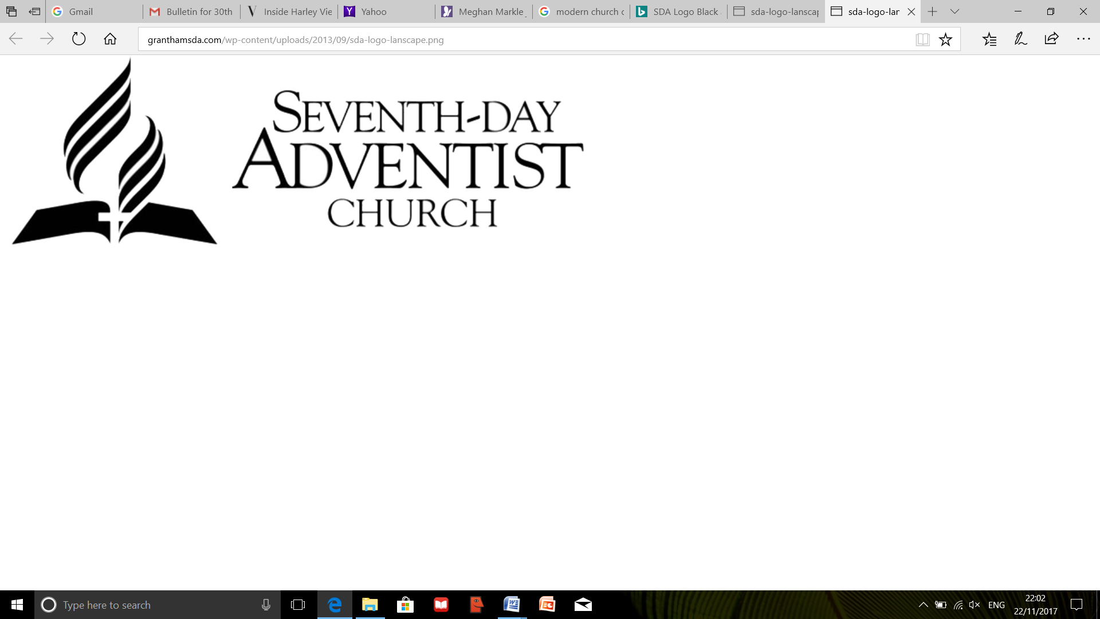



**Sabbath 07 July 2018**

Sabbath School 9.30 am

Opening Remarks Sis K Birch

Opening Hymn Sis K Birch

Opening Prayer Sis J Edwards

Scripture Reading Sis C Birch

**Lesson 1**

**You Will Be My Witnesses**

**Acts 1:8**

Welcome Sis M Richards

Mission Story

Special Item Sis C Simmons

Closing Remarks Sis K Birch

Closing Prayer Sis C Knight

**Department Promotion**

**Announcements**

Please be mindful of where your children are **AT**

**ALL TIMES** and ensure that they are supervised especially when they use the toilet facilities.

Divine Service 11.05 am

Introit Praise Team

Call to Worship Cody Marshall

Welcome Alona Caliwan

Special Item Claude Edwards

Children’s Story – Alona Caliwan

**Amara Wadibia**

Tithes and Offering Jay Baxter

Garden of Prayer Elaine Miller

Praise & Worship Praise Team

Opening Hymn 647Praise Team

Scripture Reading Elder Dwight Brown

***Ephesians 3: 3 - 10***

Meditational –

**Tottenham Gospel Choir**

Introduction- of Speaker

**Sermon** Elder Dwight Brown

***“The Mystery of God”***

Closing Hymn 200 Praise Team

Benediction Elder Dwight Brown

After the service please remain seated.

The Ushers will lead you out **reverently and quietly.**

**TODAY’S Meeting**

To be announced

**SUNSET Times**

06 July - 21:20 13 July - 21:15

20 July - 21:07 27 July - 20:58

**On Duty THIS MONTH**

Elders: Daniel Soyam & Marion Wadibia

Deacon: Earl Grant

First Aiders: Suzette Rodgers & Rosanna Russell

**Church at PRAYER**

Prayer Line - 020 8802 1477

Prayer Meeting - Wednesday 7.30pm

The Offering collected

after the Children’s Story

is in aid of our Building Fund

**BE AWARE**

The metal pipes under

the seats, are the heaters!

**Announcements**

* **The Service** can be watched on YouTube and from our Website
* **All Night Prayer Meeting -** 14 July
* **During the Renovation** - Our worship address is:

West Green Baptist Church, 182-184 West Green Road, London N15 5AF

*You are welcome to eat a light lunch in the hall after the service until 4pm*

**BULLETIN SUBMISSIONS:** By 6:00pm on Tuesday

Send your email to: **Tottenhamsda@hotmail.com**

**MONTH’S Planner**

|  |  |  |  |  |  |  |
| --- | --- | --- | --- | --- | --- | --- |
| **Date** | **14 July** | | **21 July** | | **28 July** | **4 August** |
| **Call** | Candice C | | James A | | Ranika M | Cai M |
| **Story** |  | |  | |  |  |
| **Song** | TLI | | Del & Co. | | Kelly Hunter |  |
|  | |  | |